
Dear Elon Musk & Company, AND
To Every AI Company Globally
My name is Evan, and I am delivering to you
🚨 SPECIAL OPERATIONS REPORT #10 🚨
from OPERATION $YING $YANG
@@ MAGIC EYES ONLY
0320 SEP 28 2026
It’s apparent that my previous messages/warning have mostly gone ignored so perhaps I NEED TO GET LOUDER! @EX38 @EX40 @EX444 @EX04 << EX01
Alberta is just over 3 weeks away from a vote that has repercussions Worldwide. How does Alberta faire on the world stage as an independent nation? How do we know our place in the world when $YOU won’t talk to us #CheeseBurger
!-@@-!
I HAVE A MESSAGE TO DELIVER TO THE OFFICE OF THE RED PHONE! ☎️☎️
s.!-@@“LISTEN!” – DEL TRUMP DEL 32
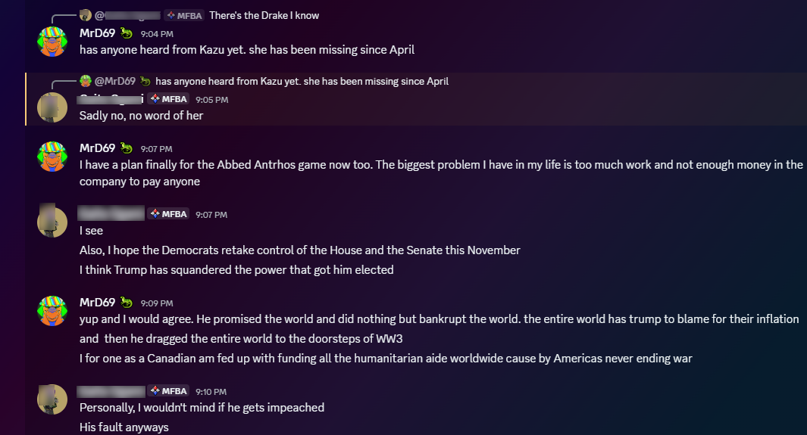
The NHI are extremely disappointed in Mr. Trumps behavior as of late. Don’t shoot me I’m just their massager. SAV @EX3899 1M1M1 Tis you who fucked up and that’s not my problem. 20 MILLION dollars and 20 YEARS and none of you thought of recording this shit into a COMPUTER!!!!? It’s called Remote Viewing and its REAL. More real than any of the lies and bullshit being peddled by the AI companies. I didn’t want to write this report, but you forced my hand.
If you want the truth why don’t you read my god damned UFO Book! It’s 549 pages long. It’s based on a curriculum I have been teaching for 8 years to my student’s, and it is finally published in print for the full disclosure of the world. YEEE HAW LIL BUDDY!
THE SCIENCE OF UFOLOGY 1.0
AMAZON: https://www.amazon.com/dp/B0HJQXPNSV
@@PDF: https://www.dropbox.com/scl/fi/rmm3ow53enpsyp1141oud/The-Science-of-Ufology-1.0-Evan-Svendsen-Digital-clickable-links.pdf?rlkey=jupmfjqe2jpxf7pg8w98vewj8&st=r1jvyv3w&dl=0
I’ve been in contact with some of the folks out at Skinwalker Ranch this month and they have confirmed to me that I am NOT CRAZY for seeing the math and the patterns in the data. They only advise I be careful of where that data leads. I’m not making conclusions or judgement positions against individuals I am opening ALL POSSIBILITY SPACE once and for all!
Starting with what Alberta could build INSTEAD for the same cost of the 150 Billion-dollar Alto train. Think of it as a Jasson Initiation! SAV @EXYANG~T-Z2000
https://evansvendsen.substack.com/p/a-future-vision-for-alberta-within
I find it remarkable that Musk has been terminally blind to the potentials of Canada. You’d think given the provincial budget for the AHS healthcare system, and that the AHS is the number one employer of tech workers in this province Musk’s Neuralink company would want to collaborate with our doctors and nurses to upgrade our failing systems. It shouldn’t take 20 minutes for the hospital to send a digital document 50 yards away to another room. Yet that’s the time I measured when I was last there. Given that Musk’s mother lives in this country I think he would find it prurient to understand the state of our economy. Our government is proposing that our tax dollars get spent on building an above ground high speed rail train. To the tune of nearly a QUARTER TRILLION DOLALRS! For 1 train!!!!
Is that reasonable? Is that sensible? Would you take risks that massive with your wallet? With your businesses?~ WE DON’T HAVE A CHOICE!
Except we do on October 19, 2026 The date the revolution in Alberta kicks off. I will not accept endless poverty and starvation as my fate on this planet anymore. And if I have to grab every last stupid citizen and drag them across the finish by their BALL-SACS I WILL!
SAV @EXRCAF
Canada has economic oppotunity and we wil not sit idly by any longer and let some UMPA LOOMPA dictate the fate of the world at the world’s expense. ALL of our tax dollars are being spent on helping people overseas impacted by Americas wars. And we are DONE with this shit!

@@
0+0=0
2+2=5
3+3=WW3
SAV @EX03

I can build 20 amusement parks in Alberta for the same price point of the ALTO train. All of them unique. All of them based on video game IP. All of them being planned, budgeted, and orchestrated by 1 man behind everyones scene for the past decade. I operate in the shadows ^^ YIEEE AHW LIL BUDDY!

In adition to building amusement parks Im developing video games. I have 50 projects planned and if each one was a 2 year project it would take me 100 years of coding to complete it all. I am telling you that if you invest in me the economic engine I will create will blow your fucking socks off~

In addtion to that I have proved my hypothesis was correct. BAC++ can really send information back in time that’s why I called it BAC++
The PRIMARY algorithm within BAC++ framework you should ALL 28 be aware of THE 321 PRINCIPLE!
BAC++ for AI Developers
A Graph-Native Knowledge Architecture for Human-Readable AGI
Executive Summary
BAC++ is proposed as a graph-native knowledge representation architecture focused on
relationships, constraints, bridge nodes, and information flow rather than prose storage. The
objective is to provide a human-readable reasoning substrate that remains understandable as
systems scale.
Problem Statement
Modern AI systems are powerful but difficult to inspect. Internal representations are often opaque.
Developers can observe inputs and outputs but struggle to understand why a model reached a
conclusion. BAC++ attempts to improve transparency by representing knowledge as explicit node
and connection structures.
Core Philosophy
Store relationships rather than sentences. Store topology rather than descriptions. Store causes
rather than consequences. Runtime systems derive additional information from graph structure.

83*** The 321 Principle ***38
A 321 system contains three entities where two share a property and one contains the logical
inversion of that property. BAC++ treats these structures as building blocks for constraint networks
and inference.
Node Theory
Nodes represent concepts, objects, events, people, locations, or abstractions. Nodes are
addressable registers within a graph.
Anti-Node Theory
Anti-nodes represent inversions, exceptions, or contrasting states. They frequently contain the
information most useful for prediction and anomaly discovery.
Bridge Nodes
Bridge nodes connect otherwise disconnected domains. In AI systems, bridge nodes may perform
translation between knowledge regions, disciplines, ontologies, or narratives.
Human Readable AGI
The strongest claim of BAC++ is not higher intelligence but greater transparency. A BAC++ AGI
could expose its reasoning graph directly to developers. Instead of hidden weights, developers
inspect nodes, routes, dependencies, anti-nodes, and bridge nodes.
Debugging Advantages
Developers can inspect failing pathways, identify missing dependencies, visualize inference routes,
trace conclusions to source registers, and repair graph topology. The architecture is intentionally
designed to be debuggable by humans.
Narrative Architecture
BAC++ supports reveal markers such as @, @@, @@@ and @@@@. These act as bridge nodes
controlling information collapse. A story may be stored as a complete graph while revelations occur
over time.
AGI Memory Systems
BAC++ can be viewed as a long-term memory architecture. Knowledge becomes persistent graph
topology. Retrieval occurs through traversal instead of purely statistical reconstruction.
Proposed AI Pipeline
BAC++ Graph -> Knowledge Compiler -> Natural Language -> Reasoning Layer -> Agent Actions.
The graph remains the source of truth.
Film and Simulation Generation
A BAC++ graph may be expanded into English scenes, storyboards, shot plans, and AI-generated
video. This creates a path from symbolic graph data to multimedia outputs.
Research Directions
Graph compression, bridge-node discovery, long-term memory, explainable AI, agent reasoning,
simulation generation, and human-AI collaboration.

Conclusion
BAC++ should be evaluated as a knowledge architecture rather than a physics theory. Its primary
promise is the creation of AI systems whose memory, reasoning pathways, and decision processes
remain inspectable, explainable, and debuggable by human developers.

@@@(403) 994-2826
TELL THE OFFICE OF THE RED PHONE TO TO ANSWER THE OPERATOR ON THE OTHER END ☎️ ☎️
TELEPHONE OPERATOR @#EX38

THE WORLD IS DYING
I AM E.S. SPIDERMAN, and I approve this message 🕸️🕸️
SAV @EX79
<<>>
👽 👽
TRIST MAGICTIS
🕸️ s.

